November 29, 2015

Mr. Gregorio Werthein
President
Federación de Ecuestre Argentina
Gorostiaga 2287
C.C. 59 Sucursal 26B
1426
Buenos Aires, Argentina

Dear Mr. Werthein,
I am writing to follow up on a discussion held during the PAEC meeting at the General Assembly regarding the unification of the competition formats and the fence heights for the following Games: Central American Games, Central American and Caribbean Games, Bolivarian Games and the ODESUR Games. The goal is to have the same competition format and standards throughout the region to ensure the qualification of NFs to the Pan American Games. Please see the proposed standards below:
ODESUR Games
Eventing CCI 1*

Dressage - Small Tour
First Day Individual and First Team- Prix. St. George
Second Day Individual and Team Final - Inter I
Third Day REST DAY
Fourth Day Freestyle Individual

Jumping Present Format Proposed Format

Speed 1.30m 1.35m
Team 1.35m 1.40m
Final Round A 1.40m 1.45m
Final Round B 1.45m 1.50m

We are currently drafting the qualification system and are requesting your formal response to the above proposed standards by December 18, 2015.
If you have any questions please contact me at your convenience.
Sincerely,
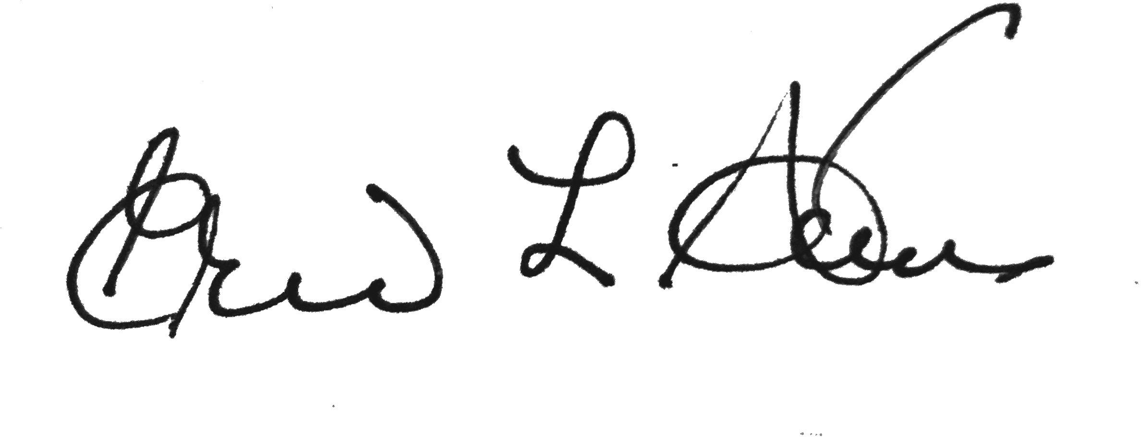
Eric L. Straus, Secretary General PAEC
Cc: Ms. Carmen Barrera, President PAEC

